 |  | Test
 |  | Test result is positive  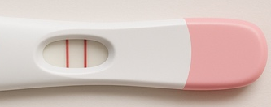 | Test result is negative  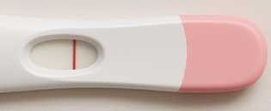
Reality | True: Susan is pregnant   | True Positive | True Negative:  Type II Error
Reality | False: Susan is not pregnant   | False Positive:  Type I Error | False Negative

Accuracy: correct / all cases | Test result is positive | Test result is negative
True: Susan is pregnant
False: Susan is not pregnant

Precision: true positive / all positive | Test result is positive | Test result is negative
True: Susan is pregnant
False: Susan is not pregnant

Recall: true positive / all true | Test result is positive | Test result is negative
True: Susan is pregnant
False: Susan is not pregnant

